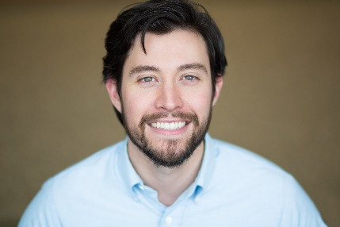
Carson Cerney
EMC
Hair: Black Eyes: Green Height: 6’0” Weight: 185 lbs.
HEYMAN TALENT - (502) 589.2540 - kathy@heymantalent.com
devin@heymantalent.com

REGIONAL THEATRE

Shakespeare in Love Will Matthew Johnson / Woodford Th.
The 39 Steps Clown 2 Shad Willingham / SRT Festival
Sylvia Greg Shad Willingham / SRT Festival
The Cake Tim / George (u/s) Shelley Delaney / Tantrum Theater
Romeo & Juliet Lord Montague / Friar John Jonathan Hetler / Ohio University
Taming of the Shrew Hortensio Andrew Felt / Pioneer Festival
Eurydice Lord of the Underworld Katie Chambers / Company J
Seussical Mr. Mayor / Wickersham Brian Kimmel / Company J
Legally Blonde Kyle / Dewey / Security Guard Brian Kimmel / Company J
Fiddler on the Roof Sasha / Dancer Brian Kimmel / Company J

UNIVERSITY THEATRE

Failure: A Love Story Mortimer Mortimer Anne McAlexander / Ohio MFA
Glengarry Glen Ross Roma Jonathan Hetler / Ohio MFA
The Library Nolan Shelley Delaney / Ohio MFA
Vessel Luke Anne McAlexander / Ohio MFA
Urinetown: The Musical Robby the Stockfish Daniel C. Dennis / Ohio MFA
Much Ado about Nothing Friar Francis Dennis Lee Delaney / Ohio MFA
Bait Shop Glenn Rani Crowe / Ohio MFA
As You Like It Silvius / Adam Ray Paolino / Univeristy of Ga.

FILM

Tripsters Lead Morgan Szymanski / Atlanta, Ga.
Beat Street Resurrection Supporting Thomas Ford / Atlanta, Ga.
Truth Seekers 2 Supporting Gaylord Parsons / Atlanta, Ga.
An Incomplete Portrait Lead Reza Mehr / Athens, Oh.
Blocking Lead Brian MacNeel / Athens, Oh.
A Spy Life Lead Morgan Szymanski / Atlanta, Ga.
Heirloom Lead Matthew Jones / Atlanta, Ga.
Hard Plastic Lead Jarryd Clark / Atlanta, Ga.
Before You See God Supporting Paul Sapp / Atlanta, Ga.
It’s A Steampunk World After All Lead Molly Wyse / Atlanta, Ga.

Education
Ohio University, M.F.A. Professional Actor Training Program
University of Georgia, B.A. Theatre & B.S. Psychology

Training
Acting: Shelley Delaney, David Haugen, George Contini, Kristin Kundert, Ray Paolino
Voice & Speech: Brian Evans, Laura Parrotti, Kristin Kundert
Movement: Rebecca VerNooy, Daniel C. Dennis, George Contini
Master Classes: Maria Aitken – Noel Coward, Alex Torra - Viewpoints (OU), Steve Coulter, BJ Hughes (Alliance Theatre). Nicolas Coster (UGA)
Brian Kimmel, Company J at the MJCCA: 2012 – 2013 Intern: Musical Theatre

Special Skills
Extensive New Play Development. Rotating Repertory Experience. Dialects: Southern American, Chicago, RP, Cockney, Irish (Belfast), Scottish. Basic Pass – Unarmed & Quarterstaff SAFD, Singing (Baritone), DJ, Football, Basketball, Sprinting, Weightlifting, and Golf.

